Please open this file on full-screen, both the application and the file. You will be able to edit this file, as long as you do not save the changes.
Rich Text Files Editor - Help

Introduction with the App
The app, named "Rich Text Files Editor", is an application that can open, edit and manage Rich Text Files, with an RTF extension.
It has all the features of a windows app, including menus, toolbars and status bar. It is a multi-window app.
There are some stylings in this help file which can help you read the file:
Caution! Text goes here.
Warning! Text goes here.
Notice! Text goes here.
Tip! Text goes here.
Do it yourself! You will be able to edit this file as long as you do not save the changes.

Notice! Shortcut Keys in this Help File
Notice! When this help file says Ctrl + O, this means you should click Ctrl and O at the same time.
Notice! But, when this help file says Ctrl > O, this means you should click Ctrl, release it, and then, click the O button.
Menus
This app, like every app, has menus.
The menus off the app are: File, Edit, Insert, Search, Format, Display, Help.
Tip! When pressing Alt on the keyboard, some letters in the menu bar will be underlined, like:
Tip! File, Edit and so on. When pressing the underlined letter, the menu will open.
Tip! Example: Alt > F will open the File menu. Of course you can still open menus by clicking them.
Toolbar
The toolbar is a line under the menus, that has icons. The icons are connected to a menu command, and instead of searching the command in the menus, you can click the icon on the menu bar.
The tool menu has icons, grouped in seperators.
Status bar
In most Windows apps, there is also a status bar.
In this app, the status bar just shows the time.
The "File" Menu
The File Menu contains the most requested commands in the world: you can open a new file, open an existing file and saving the file. You can also quit the application.
Tip! In some menu commands, there are icons near the text of the command.
Tip! The icon indicates the tool bar icon of this command.
Do it yourself! Create a new file:
Do it yourself! 1. Click on the file menu, or press Alt > F.
Do it yourself! 2. Click New.
Do it yourself! 2. Notice! Did you see the Ctrl+N text near the New text? That's a shortcut key. Instead of again and again clicking File > New, you can just press Ctrl + N.
Do it yourself! 3. Now, you have a new file you can write into it.
Do it yourself! 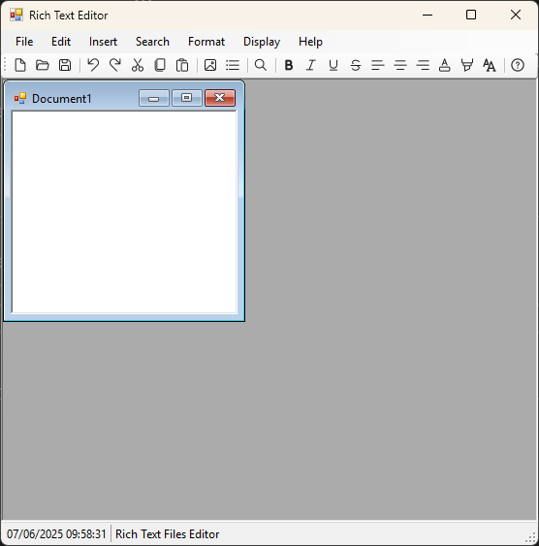]
When opening a file, it will be opened in another window, just like a new file.
Do it yourself! Open an existing file:
Do it yourself! 1. Click on the file menu, or press Alt > F.
Do it yourself! 2. Click Open. The shortcut key for this command in Ctrl + O.
Do it yourself! 3. Choose the file you want to open in the File Open Dialog. The dialog shows only RTF files.
Do it yourself! 4. The file will be in opened in another window.
Do it yourself! 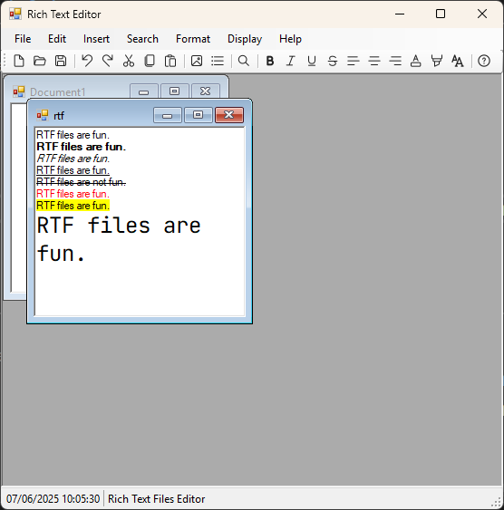
You can also save files, save files as, and close the application.
Warning! When closing the application, if there is one file or more that was not saved, the application will show a dialog box like that:
Warning! 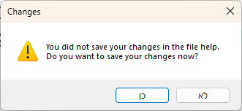
Warning! If clicking Yes (the blue button in the image), the changes will be saved and just then the application will close. A dialog window may appear so you can choose where Warning! to save the file.
Application's info
Name: Rich Text Files Editor.
Version: 1.0.0.0.
Open code sources: https://github.com/OphirBleicher/RichTextEditor.

